Name: _______________________________________________
Foundation Unit 14 topic test
Date:
Time: 60 minutes
Total marks available: 55
Total marks achieved: ______

Questions
Q1.
David is going to buy a cooker. The cooker has a price of £320
David pays a deposit of 15% of the price of the cooker.
How much money does David pay as a deposit?
£ ...........................................................
(Total for Question is 2 marks)

Q2.
Greg sells car insurance and home insurance.
The table shows the cost of these insurances.
Insurance | car insurance | home insurance
Cost | £200 | £350
Each month Greg earns
£530 basic pay
5% of the cost of all the car insurance he sells
and 10% of the cost of all the home insurance he sells
In May Greg sold
6 car insurances
and 4 home insurances
Work out the total amount of money Greg earned in May.

..............................................................................................................................................
(Total for Question is 5 marks)
Q3.
A and B are two companies.
The table shows some information about the sales of each company and the number of workers for each company in 2004 and in 2014
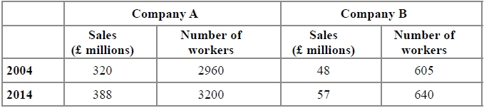
(a) Work out the percentage increase in sales from 2004 to 2014 for Company A.
........................................................... %
(2)
(b) Which company had the most sales per worker in 2014, Company A or Company B?
You must show how you get your answer.
(3)

(Total for question = 5 marks)

Q4.
There are 240 students at Walbridge school.
15% of these students are left-handed.
(a) Work out how many students are left-handed.

..............................................................................................................................................
(2)
¹⁄₃ of the 240 students are female.
(b) How many of the students are female?

..............................................................................................................................................
(1)
80 of the students walk to school.
60 of the students cycle to school.
(c) Write the ratio of the number of students who walk to school to the number of students who cycle to school.
Give your ratio in its simplest form.

..............................................................................................................................................
(2)
(Total for Question is 5 marks)

Q5.
5 schools sent some students to a conference.
One of the schools sent both boys and girls.
This school sent 16 boys.
The ratio of the number of boys it sent to the number of girls it sent was 1 : 2
The other 4 schools sent only girls.
Each of the 5 schools sent the same number of students.
Work out the total number of students sent to the conference by these 5 schools.

..............................................................................................................................................
(Total for Question is 4 marks)

Q6.
(a) Write the ratio 48 : 120 in its simplest form.
(2)
Sally has three tiles.
Each tile has a different number on it.
Sally puts the three tiles down to make a number.
Each number is made with all three tiles.
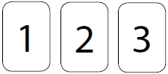
(b) How many different numbers can Sally make?
(2)
There are 60 animals at a rescue centre.
30% of the animals are cats.
38 of the animals are dogs.
The rest of the animals are horses.
(c) Work out how many horses there are at the rescue centre.
(3)

(Total for question = 7 marks)
Q7.
The value of a car depreciates by 25% each year.
At the end of 2013 the value of the car was £4800
Work out the value of the car at the end of 2015
£...........................................................
(Total for Question is 3 marks)

Q8.
Mason invests £1500 at 2.5% per year compound interest.
Work out the value of Mason's investment at the end of 3 years.
£...........................................................
(Total for question = 3 marks)

Q9.
Martin bought a computer for £1200
At the end of each year the value of the computer is depreciated by 20%.
After how many years will the value of the computer be £491.52?
You must show your working.

..............................................................................................................................................
(Total for Question is 3 marks)

Q10.
Bella invests £5000 in an account for two years.
The account pays 3% compound interest per annum.
Bella has to pay 20% tax on the interest earned each year.
This tax is taken from the account at the end of each year.
How much money will Bella have in her account at the end of the two years?

(Total for question = 4 marks)

Q11.
Here are two schemes for investing £2500 for 2 years.
Scheme A
gives 4% simple interest each year.
Scheme B
gives 3.9% compound interest each year.
Which scheme gives the most total interest over 2 years?
You must show all your working.

(Total for Question is 4 marks)

Q12.
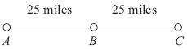
A, B and C are 3 service stations on a motorway.
AB = 25 miles
BC = 25 miles
Aysha drives along the motorway from A to C.
Aysha drives at an average speed of 50 mph from A to B.
She drives at an average speed of 60 mph from B to C.
Work out the difference in the time Aysha takes to drive from A to B and the time Aysha takes to drive from B to C.
Give your answer in minutes.

..............................................................................................................................................
(Total for Question is 3 marks)

Q13.
A piece of wood has a mass of x kg and a volume of 0.002 m³.
Show that the density of the wood is 0.5x g/cm³.

(Total for question = 4 marks)
Q14.
The diagram shows a solid triangular prism.
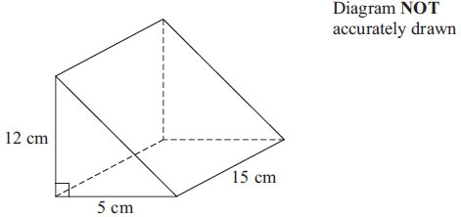
The prism is made from metal.
The density of the metal is 6.6 grams per cm³.
Calculate the mass of the prism.

..............................................................................................................................................
(Total for Question is 3 marks)

Examiner's Report
Q1.
This was generally answered well. Most students that secured 2 marks did so by first correctly finding 10% then 5% and then adding the two amounts. Others found 15% by writing 320 × 15 ÷ 100. A significant number of students worked out that 15% was 48 but then lost a mark for not reading the question properly and going on to subtract this from 320 or add it to 320.

Q2.
This was a multi-stage problem but using relatively easy mathematics. Very few candidates did formal percentage calculations, with most stating '10% is...'.
Candidates who were able to follow the question through were often successful.
Most candidates used the method of 6 × 200 and 4 × 350 first and then worked out the percentages and a number got to £200 and did not add this to £530.
Occasionally candidates worked out 10% and 5% of £530. Others mixed up the calculations for the car and home insurance. Too many added 1200 and 1400, and gave an answer of £2600.

Q3.
No Examiner's Report available for this question

Q4.
This question tested candidates understanding of finding percentages, finding a fraction of an amount and writing a ratio in its simplest form and candidates showed that they could cope with the finding 15% of 240 best (43%) followed by finding a third of 240 (40%) and writing a ratio in its simplest form was only fully correctly answered by 31% though 29% gained one mark for an incomplete solution.

Q5.
As the last question on a Foundation paper, this was still accessible to a lot of candidates.
Many managed to get started and work out 32 girls and 48 students. Some stopped at that point, gaining only two of the marks. Others then multiplied by 4, forgetting about the first school. However, many were able to carry on to successfully find 240 students. Those who tried the ratio method often came unstuck after stating three parts, commonly continuing to then divide 16 by 3. All too frequently, answers that gained no marks included those where candidates had interpreted the ratio the wrong way and proceeded to halve 16 as well as those who simply did 16 × 5.

Q6.
No Examiner's Report available for this question

Q7.
Whilst many students realised the 'compound' nature of the problem, many simply find the depreciation for one year and then doubled it for two. Some students worked out the value of the car at the end of a third year and some actually added on the 25% each year, thus increasing the value of the car.
Q8.
It remains disappointing that many students treat this as a simple interest rather than compound interest question. Those choosing to work with indices need to ensure they use the correct multiplying factor: use of 1.25³ instead of 1.125³ was a fault of some students.

Q9.
The most successful approach seen on this question was from those who used a multiplier of 0.8. Those who did generally showed evidence of 0.8^{n} × 1200 with n = 4. The more long-winded approach of taking off 20% of that year's cost for each year was also seen, although the success rate was lower. This was due mainly to poor arithmetic, although some miscounted the years and gave an answer of 5. Many candidates thought that the depreciation was linear.

Q10.
No Examiner's Report available for this question

Q11.
Too many responses used a compound interest method on scheme A to work with 4%, and answers for comparison of £2704 and £2698.80 were very common. Too many tried 'step' methods to work out the percentages – 10%, 1%, 3%, etc. – which led to inaccuracies. Some used the 4% in part (b) instead of 3.9%. Many of these problems could have been avoided with careful reading of the question.

Q12.
This question was not well done. Less than 1 in 10 candidates scored full marks with a further 2 in 10 candidates scoring part marks. The most successful candidates used a common sense approach realising that at an average speed of 50 mph Aysha would cover a distance of 25 miles in half an hour and that for the second part of the journey, a speed of 60 mph is equivalent to an average of 1 mile per minute.
A significant proportion of candidates earned the mark available for the time it took Aysha to drive from A to B, the first part of her journey. Fewer candidates obtained the correct time for the second part of the journey. Many of them gave the time taken to travel from B to C as 24 minutes. Evidence seen suggested that these candidates had worked out 60 ÷ 25 (=2.4) and interpreted their answer as 24 minutes. Many of these candidates went on to work out "30 – 24" and so earned a second mark for working out the difference of their times (with at least one correct).
Another error commonly seen was for candidates to divide speed by distance getting answers of 2 and 2.4 and then interpreting the difference as 40 minutes. Candidates often made errors converting between units of time and some weaker candidates either multiplied the speed by the distance for each part of the journey or simply found the difference between the two speeds giving their answer as "10".

Q13.
No Examiner's Report available for this question

Q14.
The volume calculation was frequently incorrect with the formula for the volume of a cuboid being calculated rather than the volume of the given triangular prism. The other common error was to divide, rather than multiply, the volume by the density to obtain the mass of the prism. Some candidates attempted to work out the surface area or find the sum of all the edges; such incorrect methods gained no marks.
Mark Scheme
Q1.
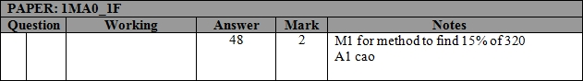

Q2.
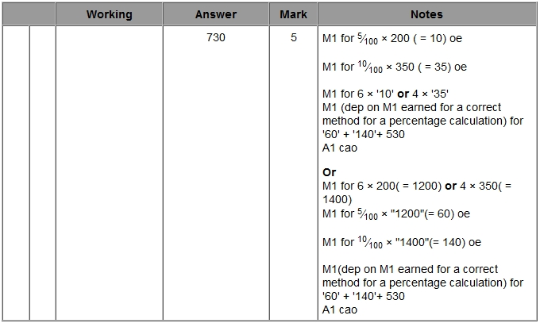

Q3.
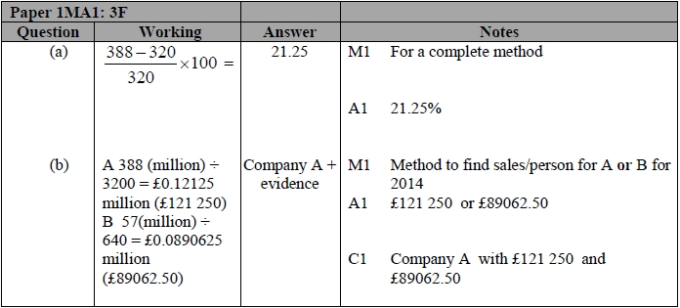

Q4.
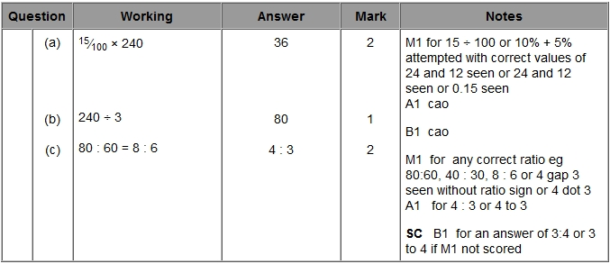

Q5.
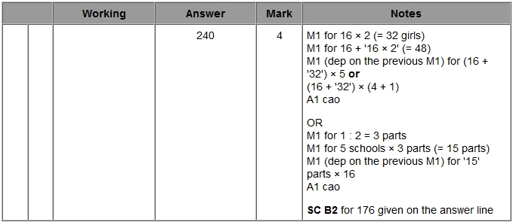

Q6.
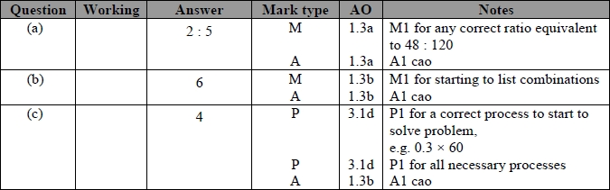

Q7.
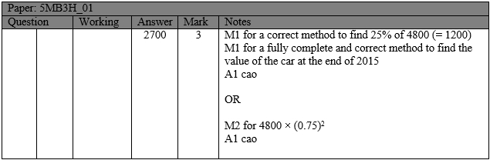

Q8.
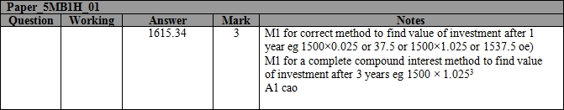

Q9.
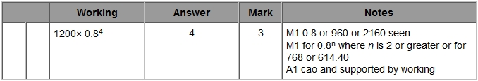

Q10.
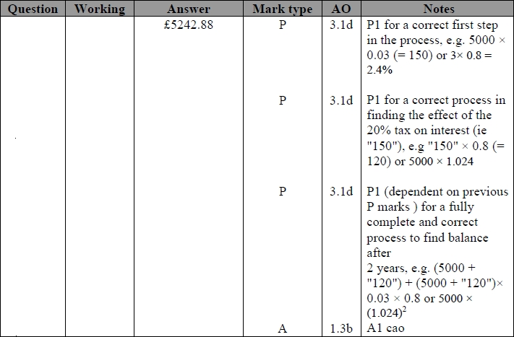

Q11.
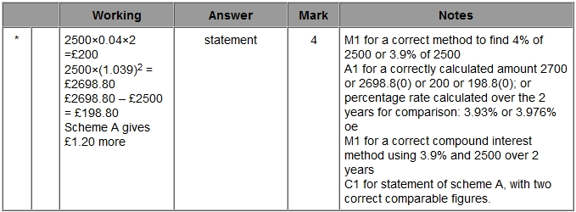

Q12.
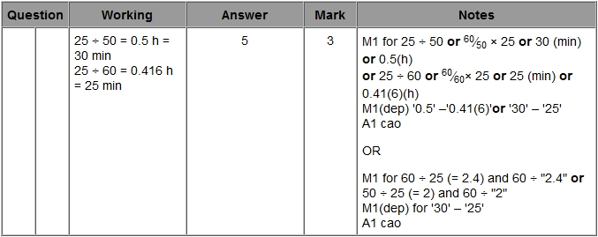

Q13.
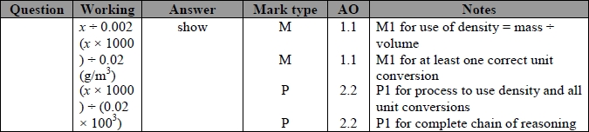

Q14.
